***naRaw code :***

Lsb_release -a

Sudo apt update

Sudo apt install nfs-kernel-server

Sudo mkdir -p /mnt/sohag

Sudo chown -R nobody:nogroup /mnt/sohag

Sudo chmod 777 /mnt/sohag

Sudo nano /etc/exports

/mnt/sohag 10.0.2.5/24(rw,syc,no_subtree_check)

Sudo exportfs -a

Sudo systemctl restart nfs-kernel-server

Sudo ufw allow from 10.0.2.15/24 to any port nfs

Sudo ufw enable

Sudo ufw status

Sudo apt install nfs-common

Sudo mkdir -p /mnt/nfs_sohag

Sudo mount 10.0.2.15:/mnt/sohag /mnt/nfs_sohag

Cd /mnt/sohag

Touch sample.text sample2.text

Cd

ls -1 /mnt/nfs_sohag

***server remove part not importance :***

sudo apt remove nfs-kernel-server

sudo apt remove nfs-common

exit

*Main Project in* ***Shell Script*** *File :*

**Step 1: Create a Shell Script File**

On the **NFS Server**, create a script:

nano setup_nfs_server.sh

Add the following code:

#!/bin/bash

# Update package lists

sudo apt update

# Install NFS server

sudo apt install -y nfs-kernel-server

# Create and configure shared directory

sudo mkdir -p /mnt/server

sudo chown -R nobody:nogroup /mnt/server

sudo chmod 777 /mnt/server

# Configure NFS exports

echo "/mnt/server 10.0.2.5/24(rw,sync,no_subtree_check)" | sudo tee -a /etc/exports

# Apply changes and restart NFS service

sudo exportfs -a

sudo systemctl restart nfs-kernel-server

sudo systemctl enable nfs-kernel-server

# Configure firewall

sudo ufw allow from 10.0.2.5/24 to any port nfs

sudo ufw enable

echo "NFS Server setup completed!"

**Save and exit (CTRL + X, then Y, then ENTER).**

**Step 2: Make the Script Executable**

Run:

chmod +x setup_nfs_server.sh

**Step 3: Run the Script**

Execute the script:

./setup_nfs_server.sh

This will **automate the NFS server setup**.

**Step 4: Create a Client Setup Script**

On the **NFS Client**, create another script:

nano setup_nfs_client.sh

#!/bin/bash

# Update package lists

sudo apt update

# Install NFS client

sudo apt install -y nfs-common

# Create mount point

sudo mkdir -p /mnt/nfs_client

# Mount the NFS share

sudo mount 10.0.2.15:/mnt/server /mnt/nfs_client

# Verify mounted directory

ls -l /mnt/nfs_client

echo "NFS Client setup completed!"

**Save and exit.**

**Step 5: Make the Script Executable**

chmod +x setup_nfs_client.sh

**Step 6: Run the Client Setup**

./setup_nfs_client.sh

**Final Test: File Sharing**

On the **NFS Server**:

nano /mnt/server/testfile.txt

Write:

Hello from the NFS Server!

**Save and exit.**

On the **NFS Client**, check the file:

cat /mnt/nfs_client/testfile.txt

If it displays the content, **your project setup is successful!**

**Project Display Picture :**

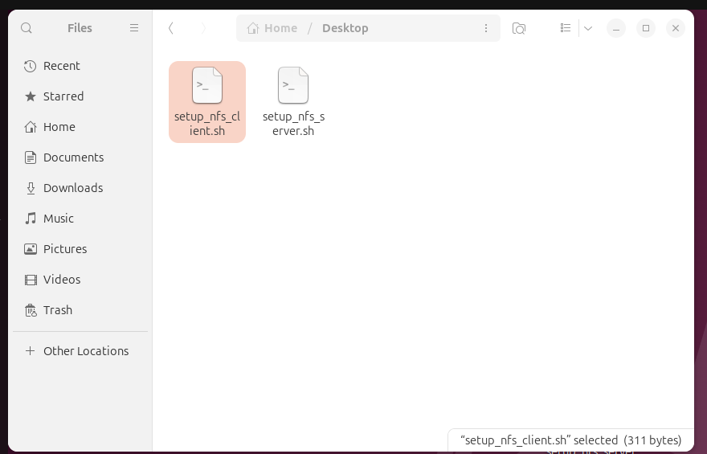

***Server Runing Part Picture :***

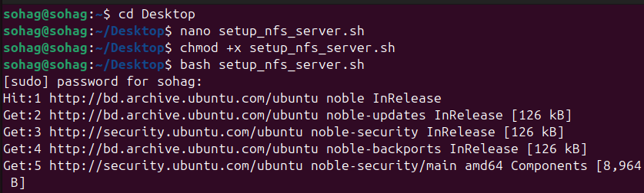

***Client Running Part Picture :***

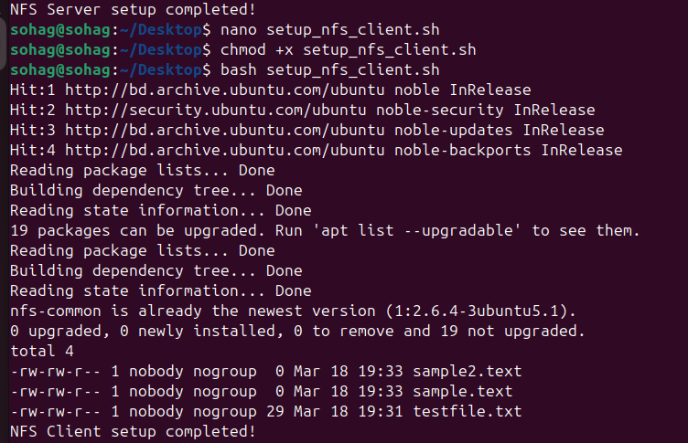

***Server From Client file transfer Test part :***

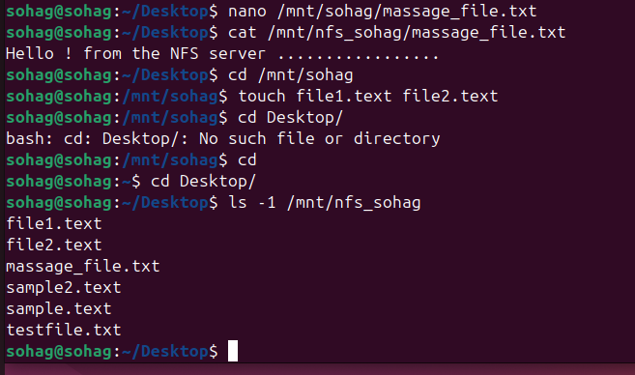

[ Note for picture part : sohag = server , nfs_sohag = nfs_client ]